|  |  |
| --- | --- |
| C:\Users\Dieter\AppData\Local\Microsoft\Windows\INetCacheContent.Word\Pepper Marketing Logo Reversed_Stacked_RGB.JPG  Software Requirements Specification  Draft Version 0.1 | Abstract  *This document incorporates the complete system requirements for the development of Peppers Telemarketing Application.*  Dieter Schmid  7/10/2016 |

Table of Contents

[1.Introduction 3](#_Toc464650499)

[1.1 Purpose 3](#_Toc464650500)

[1.2 Document Conventions 3](#_Toc464650501)

[1.3 Project Scope 3](#_Toc464650502)

[1.4 References 3](#_Toc464650503)

[2. Overall Description 4](#_Toc464650504)

[2.1 Product Perspective 4](#_Toc464650505)

[Figure 1.0 Context Diagram 4](#_Toc464650506)

[2.2 User Classes and Characteristics 5](#_Toc464650507)

[2.3 Operating Environment 5](#_Toc464650508)

[2.4 Design and Implementation Constraints 5](#_Toc464650509)

[2.5 Assumptions and Dependencies 5](#_Toc464650510)

[3. System Features 6](#_Toc464650511)

[3.1 Upload Call List 6](#_Toc464650512)

[3.1.1 User Story Description 6](#_Toc464650513)

[3.1.2 Functional Requirements 6](#_Toc464650514)

[3.2 Make Call 6](#_Toc464650515)

[3.2.1 User Story Description 6](#_Toc464650516)

[3.2.2 Functional Requirements 6](#_Toc464650517)

[3.3 Edit Call List 7](#_Toc464650518)

[3.3.1 User Story Description 7](#_Toc464650519)

[3.3.2 Functional Requirements 7](#_Toc464650520)

[3.4 Review Call Outcomes 7](#_Toc464650521)

[3.4.1 User Story Description 7](#_Toc464650522)

[3.4.2 Functional Requirements 7](#_Toc464650523)

[3.5 Administration 8](#_Toc464650524)

[3.5.1 User Story Description 8](#_Toc464650525)

[3.5.2 Functional Requirements 8](#_Toc464650526)

[3.6 Generate report 8](#_Toc464650527)

[3.6.1 User Story Description 8](#_Toc464650528)

[3.6.2 Functional Requirements 8](#_Toc464650529)

[3.7 Search Contacts 8](#_Toc464650530)

[3.7.1 User Story Description 8](#_Toc464650531)

[3.7.2 Functional Requirements 8](#_Toc464650532)

[3.8 View Call List 8](#_Toc464650533)

[3.8.1 User Story Description 8](#_Toc464650534)

[3.8.2 Functional Requirements 8](#_Toc464650535)

[4. Data Requirements 9](#_Toc464650536)

[4.1 Relational Data Model 9](#_Toc464650537)

[Figure 4.0 Data Base Design 9](#_Toc464650538)

[4.2 Data Dictionary 9](#_Toc464650539)

[4.3 Reports 10](#_Toc464650540)

[4.4 Data Integrity, Retention, and Disposal 11](#_Toc464650541)

[5. External Interface Requirements 12](#_Toc464650542)

[5.1 User Interfaces 12](#_Toc464650543)

[Figure 5.0 Flow of Screens 12](#_Toc464650544)

[5.2 Software Interfaces 12](#_Toc464650545)

[5.3 Hardware Interfaces 13](#_Toc464650546)

[5.4 Communications Interfaces 13](#_Toc464650547)

[6. Quality Attributes 14](#_Toc464650548)

[6.1 Usability Requirements 14](#_Toc464650549)

[6.2 Performance Requirements 14](#_Toc464650550)

[6.3 Security Requirements 14](#_Toc464650551)

[6.4 Safety Requirements 14](#_Toc464650552)

[6.5 Availability Requirements 14](#_Toc464650553)

[6.6 Robustness Requirements 15](#_Toc464650554)

[Appendix A. Major User Cases 16](#_Toc464650555)

[Appendix B. Major Screen Wireframe 24](#_Toc464650556)

[Picture B.1 Design 1 Wireframe Telemarketing Screen 1024 x 768. 24](#_Toc464650557)

[Picture B.2 Design 2 Wireframe Telemarketing Screen 1920 x 1080. 25](#_Toc464650558)

[Picture B.3 Wireframe Account Database linking screens 26](#_Toc464650559)

[Picture B.4 Wireframe Contact Database linking screens 27](#_Toc464650560)

[Picture B.5 Create Campaign Screen 28](#_Toc464650561)

[Picture B.6 Call list outcome review screen 29](#_Toc464650562)

# 1.Introduction

## 1.1 Purpose

This SRS describes the functional and non-functional requirements for the software release 1.0 of the Pepper Telemarketing System (PTS). This document is intended to be used by members of the project team who will implement and verify the correct functioning of the system. Unless otherwise noted, all requirements specified here are committed for release 1.0.

## 1.2 Document Conventions

There are no special typographical conventions used in this SRS.

## 1.3 Project Scope

The PTS shall be able to take in data relevant to a client’s telemarketing requirements and allow for telemarketing to occur in order to meet those requirements. A detailed description is available in the *Business Vision and Scope Specification Document 1.0* along with a list of major features to be scheduled for this release.

## 1.4 References

Wiegers, K.E. and Beatty, J. (2013) *Software requirements 3*. 3rd edn. United States: Microsoft Press.

Stephens, R. (2015) *Beginning software engineering*. Hoboken, NJ, United States: John Wiley & Sons.

Roman Pichler, 2010. *Agile Product Management with Scrum: Creating products that Customers Love* (Addison-Wesley Signature Series(Cohn)). 1 Edition. Addison-Wesley Professional

# 2. Overall Description

## 2.1 Product Perspective

The Pepper Telemarketing System is a new software system that replaces the current manual system for making telemarketing calls and managing the data that is used in the process. Currently this is all done through excel documents. The context diagram in figure 2.1 illustrates the external entities and system functions in release 1.0. Further enhancement to the product have been documented in the *Business Vision and Scope Specification Document 1.0,* as it is expected to evolve beyond this release. The most likely improvement will be in terms of offering more functions that hook into the database such as the ability to make query’s around the information stored.

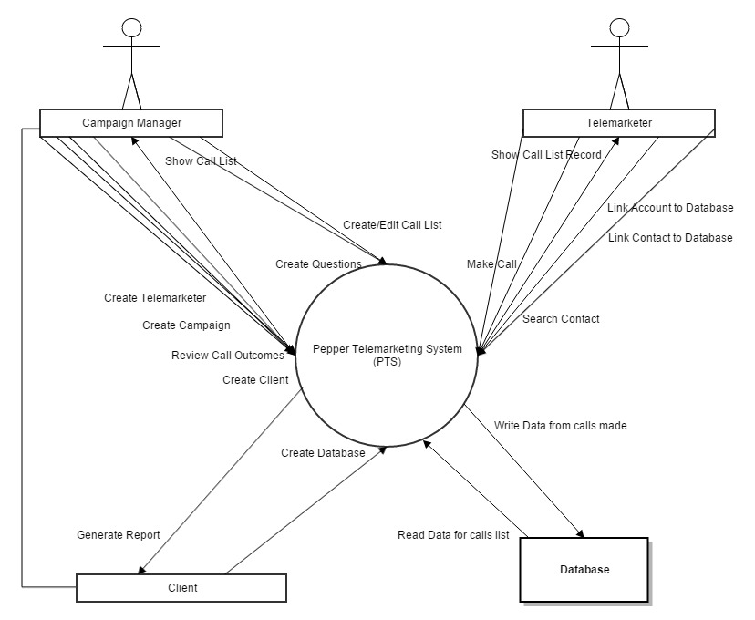

### Figure 1.0 Context Diagram

## 2.2 User Classes and Characteristics

|  |  |
| --- | --- |
| **User Class** | **Description** |
| Campaign Manager | The campaign manager is an employee of Pepper Marketing who manages all aspects of the telemarketing campaign. This includes working with a client to determine the contacts to call, and the electronic direct mail to be sent as a precursor to the telemarketer making the calls. They also manage the briefing process and provide a call script, as well as profiling questions that are to be asked during the Telemarketers call. |
| Telemarketer | The telemarketer may be a direct employee of Pepper Marketing or an external contractor. The telemarketer will make calls to the contact data in the system and update the contact and account records with information and specific outcomes from the calls made. |

## 2.3 Operating Environment

The PTS front end GUI will be operable on the following browsers

* Chrome 52
* Safari 9.1
* Edge 14
* Firefox 48
* Internet Explorer 11
* Opera 39

1-year backwards compatibility should be accounted for.

The backend system will be reviewed. The expectation is that the software will run in the cloud, however the actual technology operating environment will evaluated as part of the high level design.

## 2.4 Design and Implementation Constraints

There are no specific design and implementation considerations. The developers are allowed to make a best fit for purpose choice of technology.

## 2.5 Assumptions and Dependencies

It is assumed that function to make calls will be done via a VOIP phone arrange either by Pepper Marketing or the Telemarketer themselves and is not part of this software system.

Refer to *Business Vision and Scope Specification Document 1.0,* for further assumptions and dependencies.

# 3. System Features

## 3.1 Upload Call List

### 3.1.1 User Story Description

As a campaign manager I want to be able to upload a call list into the system, which has defined row headers with Mandatory, optional and custom fields, for the telemarketers to make calls from.

***\*\*\*As a campaign manager I want to be able to allocate a portion of contacts on the call list to multiple telemarketers i.e. split the list up\*\*\* ?***

### 3.1.2 Functional Requirements

**.upload**: The PTS shall read the filename of the call list to be uploaded and store the file in the database.

**.name**: The PTS shall allow the Campaign Manager user to label the call list file name

**.validateMandatory:** The PTS shall check the call list has all Mandatory fields.

**.validateOptional:** The PTS shall check which optional field have been included.

**.validateCustom:** The PTS shall check if there is up to 10 custom fields.

Custom (optional and can be defined as anything else)

Mandatory (must have these headers)

Optional (Can be included)

|  |
| --- |
| **Column Headers** |
| First Name |
| Phone |
| Last Name |
| Company |
| Email |
| Job Title |
| Phone Direct |
| Mobile |
| State |
| Country |
| Size |
| Industry |
| eDM 1 | status |
| eDM 2 | status |
| eDM 3 | status |
| eDM 4 | status |
| Custom 1 |
| Custom 2 |
| Custom 3 |
| Custom 4 |
| Custom 5 |
| Custom 6 |
| Custom 7 |
| Custom 8 |
| Custom 9 |
| Custom 10 |

## 3.2 Make Call

### 3.2.1 User Story Description

As a Telemarketer I want to be able to select a list of contacts to call.

As a Telemarketer I want to be able to see the all the information I need about a contact to make a call.

As a Telemarketer I want to be able to see the all the information I need about an account to make a call.

As a Telemarketer I want to be able to see the all the information I need about a call brief to make a call.

As a Telemarketer I want to be able to cross reference the contact details with details stored in the systems database to see if there is a link to prior history.

As Telemarketer I want to be able to cross reference the Account details with details stored in the systems database to see if there is a link to prior history.

As a Telemarketer I want to be able to save changes to the Contact details and have them saved to the database.

As a Telemarketer I want to be able to save changes to the Account details and have them saved to the database.

As a Telemarketer I want to be able to create a new contact and have them saved into the database

As a Telemarketer I want to be able to reject a contact if the data is invalid

As a Telemarketer I want to be able to edit designated contact fields  
As a Telemarketer I want to be able to edit designated account fields

### 3.2.2 Functional Requirements

**.select**: The PTS shall allow the telemarketer user to select the call list of the client and campaign they want to make calls too.

**.viewContact:** The PTS shall provide a view of all contact information the telemarketer needs to see in order to make a call.

**.viewAccount:** The PTS shall provide a view of all Account information the telemarketer needs to see in order to make a call.

**.viewScript:** The PTS shall provide a view of the script and briefing links the telemarketer needs to see in order to make a call.

**.validateAccount**: The PTS shall allow the telemarketer user to confirm if the account they are calling is already stored in the database by viewing all ‘like named’ accounts in the database. If it is in the database the telemarketer can then choose to link the accounts and is prompted to update with the latest information before saving to the database.

**.validateContact**: The PTS shall allow the telemarketer user to confirm if the contact they are calling is already stored in the database by viewing all ‘like named’ contacts in the database. If it is in the database the telemarketer can then choose to link the contacts and is prompted to update with the latest information before saving to the database. The contact is also linked to the account saved in the database.

**.saveAccount**: The PTS shall allow the telemarketer user to save account details they are calling if the Account is already stored in the database. If the account is not in the database the system will prompt the Telemarketer user to link the account to an existing account in the database, if no account exist a new Account will be written to the database.

**.saveContact**: The PTS shall allow the telemarketer user to save contact details they are calling if the contact is already stored in the database and their account also exists in the database. If the contact is not in the database the system will prompt the Telemarketer user to link the contact to an existing contact in the database, if no contact exists a new Account will be written to the database.

**.newContact:** The PTS shall allow the telemarketer to add a new contact to the database, when necessary as part of the telemarketers calling. This contact will be saved and linked to the appropriate account in the database.

**.rejectContact:** The PTS shall allow the telemarketer to reject the contact from being written to the database. (Any rejected contacts should be highlighted in the review call list)

**.editContact:** The PTS shall allow the telemarketer to double click on a contact data field, which provides an editing prompt to change the value.

**.editAccount:** The PTS shall allow the telemarketer to double click on a account data field, which provides an editing prompt to change the value.

## 3.3 Edit Call List

### 3.3.1 User Story Description

As a campaign manager I want to be able to edit the contacts, and make changes to the call list that has been uploaded to the system.

As a campaign manager I want to be able to adjust the call list to eliminate or include particular contacts

### 3.3.2 Functional Requirements

**.editCallListContacts:** The Campaign Manager can select to remove a contact from the call list or filter the call list of contacts based on the column headers in the call list file.

## 3.4 Review Call Outcomes

### 3.4.1 User Story Description

As a campaign manager I want to be able to edit comments from the results of calls made by a telemarketer to a call list.

As a campaign manager I want to be able to review the results of calls made by a telemarketer to a call list.

### 3.4.2 Functional Requirements

**.editResults:** The PTS shall allow the Campaign Manager to select a call list and edit the results of calls made to the call list by a specific telemarketer.

**.reviewResults**: The PTS shall allow the Campaign Manager to select a call list and view the results of calls made to the call list by a specific telemarketer and select to approve the results of calls made.

## 3.5 Administration

### 3.5.1 User Story Description

As a campaign manager I want to create a campaign to upload a call list to and associate it with a client

As a campaign manager I want to create a client or associate a campaign to an existing client

As campaign manager I want to add a tele brief to a campaign.

As a campaign manager I want to add additional profiling questions if needed to a campaign

### 3.5.2 Functional Requirements

**.createCampaign:** The PTSshall allow the campaign manager to select a client and create a campaign under the client.

***.createEDMs:*** *The PTS shall allow the campaign manager to select a client and campaign and store the electronic direct mails used in the campaign in the database, as well as create a filename in the database for the EDM.*

**.createQuestions:** The PTS shall allow the campaign manager to create customer profiling questions for the campaign and store the questions and the answers in the database.

## 3.6 Generate report

### 3.6.1 User Story Description

As a campaign manager I want to produce a report that details the results of calls made to a list of contacts.

### 3.6.2 Functional Requirements

**.showReport:** The PTS shall display the results of a calls made to a call list and allow the campaign **.downLoadList**: The PTS shall make a download link so that the report can be saved as a excel document file to be downloaded and sent to the customer.

## 3.7 Search Contacts

### 3.7.1 User Story Description

As a Telemarketer I want to search contacts in the database to review and call.

### 3.7.2 Functional Requirements

**.searchContact:** The PTS shall allow the telemarketer tosearch for a specific contact allocated to a call list that is in the database, and view this contact in the telemarketer call screen.

## 3.8 View Call List

### 3.8.1 User Story Description

As a Telemarketer I want to be able to view call lists assigned to me.

### 3.8.2 Functional Requirements

**.select**: The PTS shall allow the telemarketer user to select the call list of the client and campaign they want to make calls too.

# 4. Data Requirements

## 4.1 Relational Data Model

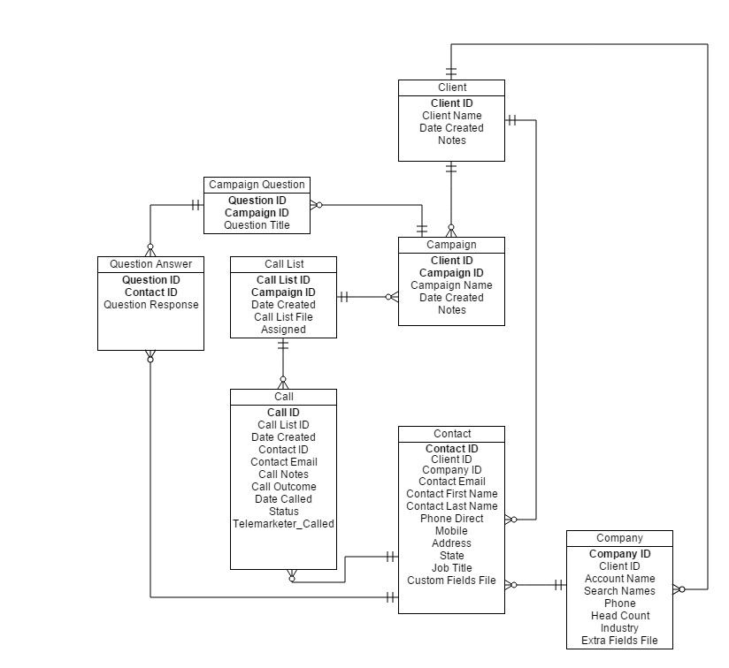

### Figure 4.0 Data Base Design

## 4.2 Data Dictionary

Definition of all data fields being read into the system.

|  |  |
| --- | --- |
| **Data Field Name** | **Data types** |
| Client ID | INTEGER |
| Client Name | VARCHAR |
| Data Created | TIMESTAMP |
| Notes | VARCHAR |
| Campaign ID | INTEGER |
| Campaign Name | VARCHAR |
| Asset ID | INTEGER |
| Asset Name | VARCHAR |
| Email Contents | VARCHAR [*filename*] |
| Contact ID | INTEGER |
| Email | VARCHAR |
| Question ID | INTEGER |
| Question Title | VARCHAR |
| Question Response | VARCHAR |
| Call List ID | INTEGER |
| Call List File | VARCHAR [*filename*] |
| Assigned | VARCHAR |
| Contact Email | VARCHAR |
| Call Notes | VARCHAR |
| Date Called | TIMESTAMP |
| Status | BOOLEAN |
| Telemarketer Called | VARCHAR |
| Account ID | INTEGER |
| Contact First Name | CHARACTER (20) |
| Contact Last Name | CHARACTER (20) |
| Phone Direct | CHARACTER (20) |
| Mobile | CHARACTER (20) |
| Address | VARCHAR |
| State | CHARACTER (5) |
| Job Title | CHARACTER (30) |
| Account Name | CHARACTER (30) |
| Search Names | VARCHAR (XML ?) or ARRAY |
| Phone | CHARACTER (20) |
| Head Count | INTEGER |
| Industry | CHARACTER (30) |
| Extra Fields File | VARCHAR [*filename*] |
| Call Outcome (Drop Down Box Fields) | |  | | --- | | General interest, Client to call | | Opportunity identified - meeting booked | | Future opportunity, nurture | | Direct opt-in | | Referred opt in | | No interest | | Referred to colleague, new contact added | | Left company, replacement found | | Left company, no replacement | | Unable to contact | | VM1 | | VM2 | | VM3 | | Unsubscribe | | Existing opp, Client engaged | | Invalid number  Reseller | | Existing Customer | |

## 4.3 Reports

Formatting of the reports to be generated.

|  |  |
| --- | --- |
| **Report ID** | Call List Outcomes - 1 |
| **Report Title** | **Call Outcomes** |
| Report Purpose | For the Campaign Manager who wants to see a list of the contacts called and outcomes of the calling. This is to be presented to the client. |
| Priority | High |
| Report Users | Campaign Managers |
| Data Sources | Generate from a record of contacts called in the database. |
| Frequency and Disposition | The report is generated every time a telemarketer has called through the list. The report is displayed in an excel format in the web browser and is downloadable. |
| Latency | Complete report must be displayed to the Campaign manager within 5 seconds of its request. |
| Visual Layout | Excel Document |
| Header and Footer | Report header shall contain the report title, Campaign Managers name, campaign name, and date. |
| Report Body | ***Tab 1 – Summary Tab, Calling results.***  Displays a summary of the call lists, appointments made, calls made, contacts spoken to.  ***Tab 2 – The Calling details***  Fields (TBD)  Job Title  Phone  Phone Direct  Mobile  New Contact  Call Outcome  Call Notes  Call Data & Time  Question 1  Question 2  Question 3  Question 4  EDM [name] Status 1  EDM [name] Status 2  EDM [name] Status 3  EDM [name] Status 4  ***Tab 3 – Only the Details of generated leads.***  Job Title  Phone  Phone Direct  Mobile  New Contact  Call Outcome  Call Notes  Call Data & Time  Question 1  Question 2  Question 3  Question 4 |
| End-of-Report-Indicator | Last call row. |
| Interactivity | Downloads as Excel document that can be edited. |
| Security Access Restrictions | Only a Campaign Manager can download a report. |

## 4.4 Data Integrity, Retention, and Disposal

All data is to be stored long term (100 years) in the PTS, after 5 years it may be archived off, depending on size and cost of storing the data long term, and where to store the data.

# 5. External Interface Requirements

## 5.1 User Interfaces

Screens of the user interfaces will be as follows.

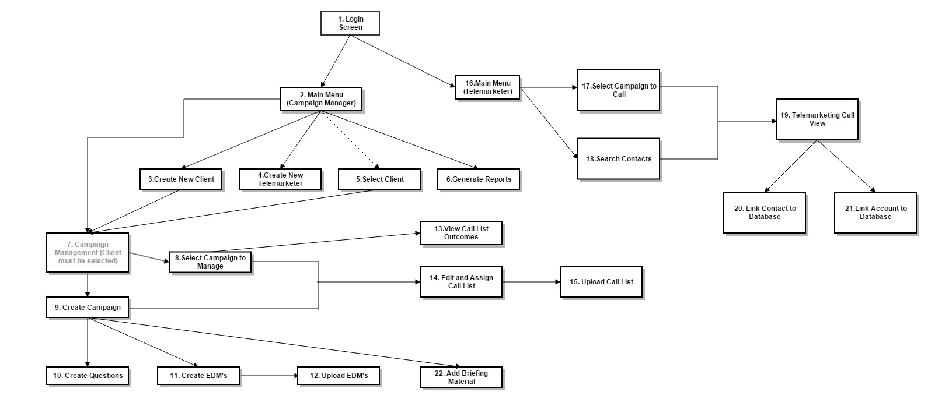

### Figure 5.0 Flow of Screens

UI-1 Login Screen

UI-2 Main Menu (Campaign Manager)

UI-3 Create New Client

UI-4 Create Telemarketer

UI-5 Select Client

UI-6 Generate Reports

UI-7 Campaign Management

UI-8 Select Campaign to Manage

UI-9 Create Campaign

UI-10. Create Questions

UI-11. Create EDM’s

UI-12. Upload EDM’s

UI-13. View Call List Outcomes

UI-14. Edit and Assign Call List

UI-15. Upload Call List

UI-16. Main Menu (Telemarketer)

UI-17. Select Campaign to Call

UI-18. Search Contacts

UI-19. Telemarketing Call View

UI-20. Link Contact to Database

UI-21. Link Account to Database

UI-22. Add Briefing Material

## 5.2 Software Interfaces

This is a standalone application. Initial iteration will not have any additional interfaces other than to the back end logic and database.

SI-1 Front end web client

SI-2 Back end server

SI-3 Database

(SI-4) – Consideration for interface into salesforce, or an API to be able to interface into other CRM’s that the pepper marketing team use need to be considered.

## 5.3 Hardware Interfaces

There are no hardware interface requirements.

## 5.4 Communications Interfaces

The PTS does not communicate via any medium, other than as a web based application. There is no requirement for sending email or otherwise.

# 6. Quality Attributes

## 6.1 Usability Requirements

USE-1 The PTS shall allow easy upload of call lists in a timely manner, as well as the ability to easily edit and view the call lists. This shall occur with instantaneous response times.

USE-2 The PTS shall be intuitive for the telemarketer to use, and prevent mistakes from being made. All call screens shall respond instantaneously, as the telemarketer requires to navigate through the call quickly. No back end load times should hamper the calling, so database reads and writes shall happen instantaneously.

USE-3 The PTS shall opt for simplicity as a design concept, and avoid over cluttering of the interface. Only components useful to workflow shall be displayed.

USE-4 The PTS at a minimum will work to minimum resolutions of 1024 x 768 which will display needed functionality, however the assumption is that users should have 1920 x 1080 access.

|  |  |
| --- | --- |
| **Priority** | **Screen resolution** |
| 1.Working in standard desktop HD resolution | 1920 x 1080 |
| 2.Laptop, small screen 11” and above | 1366 x 768 |
| 3.Laptop old, small screen 11” and above | 1024 x 768 |

## 6.2 Performance Requirements

PER-1 The system must accommodate for multiple users. It will scale as more telemarketers use the system, anywhere from 1 to 10 is probable although the technology could scale to large amounts of users if enough computing power is provided.

PER-2 As a web application the system shall run as quickly as possible over a home based ADSL connection. This means minimal graphics and use of local client compute load. It will be free of errors, and 99.9% stable.

## 6.3 Security Requirements

SEC-1 All transactions with personally identifiable information shall be encrypted when transferring to the back end database.

SEC-2 User login names and password are required for accessing the application. Password details are encrypted and stored in the database.

SEC-3 Telemarketers are only able to access the telemarketing parts required to do their job in the system, and have no access to other parts of the system.

## 6.4 Safety Requirements

SAF-1 The system will work to adhere to high screen resolutions 1920 x 1080 and above, working correctly with any input devices commonly used in the office that suits ergonomic purposes.

## 6.5 Availability Requirements

AVL-1 The system should maintain 99.9% uptime, its main usage will be between 9am and the 5pm EST. Although administrational tasks could occur at any time in the system. Any maintenance will happen outside these hours.

## 6.6 Robustness Requirements

ROB-1 If the internet connection is broken, the system will move into an offline state, where it will stop calls from being made. It should also enable the user’s session to be recovered when the system comes back online.

ROB-2 The database must also be accessible for the PTS to work properly. If the database connection goes down, or cannot be accessed, the system should stop all interactions and calling being made. Once back up and connect the system should resume as normal.

ROB-3 Any updates or maintenance shall occur outside of business hours; the PTS shall always be ready to operate during business hours.

# Appendix A. Major User Cases

|  |  |
| --- | --- |
| **Primary Actor** | **Use Cases** |
| Campaign Manager | 1. Setup Campaign 2. Create a call list 3. Edit a call list 4. Generate Report 5. Review calls made |
| Telemarketer | 1. Make Call 2. Search Contact |

|  |  |
| --- | --- |
| **ID and Name:** | **UC-1 Setup Campaign for New Client** |
| Created By: | |  |  |  | | --- | --- | --- | | Dieter Schmid | Date Created : | 7/10/2016 | |
| Primary Actor: | Campaign Manager |
| Description: | A campaign manager logs into the system from a compatible web browser on any machine, and selects to create a client, adds in the client’s details and then goes to create a campaign in the system. By selecting create campaign from the menu the user is presented with a screen that requires the campaign name to be entered. It also requests that any electronic direct mail sent in the campaign be uploaded and attached to the campaign. Any profiling questions that the user wants to be asked by the telemarketer when calling are also added in this screen. Once done the campaign is saved. |
| Trigger: | A campaign manager wants to start a call campaign for a new/existing client. |
| Preconditions: | PRE-1 The campaign manager is logged into the system.  PRE-2 The campaign manager has the EDM’s ready to upload. |
| Postconditions: | POST-1 The new client details are stored in the database.  POST-2 The campaign details are stored in the database, including EDM’s and questions associated with the campaign.  POST-3 The Campaign Manager is presented with the screen to download/upload a Call List. |
| Normal Flow: | 1. Setup Campaign for new client   1 Campaign Manager select create client from the menu  2 Campaign Manager enters details for the client  3 Campaign Manager saves details  4 Campaign Manager enters Campaign details  5 Campaign Manager enters EDM’s details, uploads EDM’s  6 Campaign Manager enters Questions.  7 Campaign is saved |
| Alternative Flows: | 1.1 Setup Campaign for existing client  1 Campaign Manager goes to select existing client from menu  Return to step 4.  1.2 Setup existing Campaign for client  4 Select edit Campaign details  Return to step 5.  1.3 EDM upload is wrong and needs to be deleted.   1. Select EDM’s to be delete 2. Press delete   1.4 Questions entered is wrong and needs to be deleted.   1. Select EDM’s to be deleted 2. Press delete |
| Exceptions: |  |
| Priority: | High |
| Frequency of Use: | Medium |
| Business Rules: | BR-1 A client can have many campaigns.  BR-2 A campaign can have up to 4 EDM’s.  BR-3 A campaign can have up to 4 profiling questions.  BR-4 Once a campaign is saved you cannot change the questions or the EDM. |
| Other Information: | 1. Campaign and Client save will be implemented as permanent, delete function will need to be added. |
| Assumptions: | An administrator account has already been made for the Campaign Manager. |

|  |  |
| --- | --- |
| **ID and Name:** | **UC-2** Create Call List |
| Created By: | |  |  |  | | --- | --- | --- | | Dieter Schmid | Date Created : | 7/10/2016 | |
| Primary Actor: | Campaign Manager |
| Description: | A campaign manager has an excel sheet of data they want to upload into the system for the telemarketer to make calls from. They log into the system select the client and campaign they want to make calls to and then select upload and create list. A name to save the list is entered and an upload button is pressed which provides a folder screen to select the list to upload. The list is selected and the upload button is pressed again to close the folder screen. The system reads in the list checking for formatting errors. Errors are show in a dialogue box, to be fixed in the excel and re-uploaded. Once successfully uploaded the user is then presented with a screen showing the list as it has been uploaded, in the edit list screen. |
| Trigger: | Campaign Manager has a new list that has to be enter into the system |
| Preconditions: | PRE-1 – Campaign manager is logged in  PRE-2 – Campaign manager has selected a client and campaign  PRE-3 – Campaign manager has a call list ready to load |
| Postconditions: | POST-1 – The screen displayed has changed to the edit screen  POST-2 – Call list is store in the database. |
| Normal Flow: | 2.0- Setup Campaign for new client  1.Excel call list is prepared by the campaign manager  2.The campaign manager logs into the system  3.A Client is selected from main menu  4.Campaign management is selected  5.Upload Call list is selected  6.The name of the call list is entered and uploaded  7.Call list is processed by the system  8. Successful upload presents the user with a dialogue.  9. The user is automatically navigated to the edit call list screen |
| Alternative Flows: | 2.1 – Call list validation error is produced  8. Dialogue is presented to the user, indicating the error, call list is not processed.  9. The excel call list errors are corrected by the campaign manager.  Return to step 6. |
| Exceptions: | 2.0.E1 The call list does not conform to the convention of columns/rows required. |
| Priority: | High |
| Frequency of Use: | Medium |
| Business Rules: | BR-1 Excel call list must meet a column header convention. (TBD)  BR-2 A campaign can have multiple call lists. |
| Other Information: | The call list will be saved permanently to the database, including the excel file itself. |
| Assumptions: | An administrator account has already been made for the Campaign Manager. |

|  |  |
| --- | --- |
| **ID and Name:** | **UC-3** Edit Call List and Assign |
| Created By: | |  |  |  | | --- | --- | --- | | Dieter Schmid | Date Created : | 7/10/2016 | |
| Primary Actor: | Campaign Manager |
| Description: | A Campaign Manager has logged into the system and wants to view a call list that has been uploaded so it can be edited. The Campaign Manager selects the client and the campaign they want. They then select the edit and assign call list menu options. They are prompted with a drop list of possible call lists from which they select the one appropriate to the one they want to edit. The call list is displayed on screen. The campaign manager is then able to make changes to the call list. A contact can be hidden or shown, or the call list can be filtered on a call list column field. Once the editing is completed the campaign manager then selects the Telemarketer for the call list to be assigned to. |
| Trigger: | Campaign Manager wants to make changes and edit a call list already in the system. |
| Preconditions: | PRE-1 Campaign Manager has an account on the system and is logged in.  PRE-2 Call lists have been uploaded to the system to be edited. |
| Postconditions: | POST-1 The edited call list is available to the telemarketer assigned.  POST-2 The call list reflects the edited changes.  POST-3 Only calls filtered on are flagged to be called by the telemarketer |
| Normal Flow: | 1. - Edit Call List and Assign 2. The campaign manager logs into the system 3. A Client is selected from main menu 4. The edit call list and assign option is selected 5. The call list to be edited is selected from the drop down menu 6. The contacts to be hidden and shown are selected 7. The list can be filtered by column header 8. The values in the call list are edited 9. The call list is saved and assigned to a telemarketer |
| Alternative Flows: |  |
| Exceptions: | 2.0.E 1 A wrong value is entered into a call list  7. A validation error is present and the value is return to its previous value.  Return to step 7. |
| Priority: | High |
| Frequency of Use: | Medium |
| Business Rules: | BR-1 Row and Columns in the call list cannot be deleted only values changed. |
| Other Information: |  |
| Assumptions: | All data comes from an excel file, not the back end data base. |

|  |  |
| --- | --- |
| **ID and Name:** | **UC-4** Generate Report |
| Created By: | |  |  |  | | --- | --- | --- | | Dieter Schmid | Date Created : | 7/10/2016 | |
| Primary Actor: | Campaign Manager |
| Description: | A Campaign Manager has logged in to the system. The campaign manager selects to generate a report. The campaign manager must choose the client, the campaign and the call list (*is it possible to generate a report for a whole campaign and merge the call lists?*). They then select to generate a report. A report appears on screen with an option to download. |
| Trigger: | A campaign manager requires a report. |
| Preconditions: | PRE-1 Campaign Manager has an account on the system and is logged in.  PRE-2 Calling to the call list has been complete |
| Postconditions: | POST-1 A excel report is generated, onto the web browser screen.  POST-2 A link to download the excel document is created. |
| Normal Flow: | 1. Generate Report 2. Campaign Manager logs into the system. 3. The campaign manager selects to generate a report. 4. The campaign manager selects the client. 5. The campaign manager selects the campaign. 6. The campaign manager selects the call list. 7. The report is generated and displayed on screen 8. The report is download via a link. |
| Alternative Flows: |  |
| Exceptions: | 3.0.E1 There is no client, no report can be generated  3.0.E2 There is no campaign, no report can be generated  3.0.E3 There is no call list, no report can be generated |
| Priority: | High |
| Frequency of Use: | Medium |
| Business Rules: | BR-1 All rows and columns from the call list are include in the report  BR-2 The report shall provide a summary report tab which is automatically generated. |
| Other Information: |  |
| Assumptions: | That calls have been made to the call list being reported on, and approved by the campaign manager. |

|  |  |
| --- | --- |
| **ID and Name:** | **UC-5 Review Calls Made** |
| Created By: | |  |  |  | | --- | --- | --- | | Dieter Schmid | Date Created : | 7/10/2016 | |
| Primary Actor: | Campaign Manager |
| Description: | The Campaign Manager will log into the system and select a client and campaign. They will then select to view calls made under that campaign that have been assigned to a telemarketer. This will be sorted under each call list ***(****or there may be a requirement to view all calls made under a campaign****).*** The campaign manager can choose to see any calls made in the list, and not show calls made or see all calls. From the list display the campaign manager will be able to go in review and edit values in the call list. Once a call list is reviewed and approved it is made available to be generated in a report. |
| Trigger: | Campaign manager wishes to review calls made to a call list by the telemarketer |
| Preconditions: | PRE-1 The campaign manager is logged into the system.  PRE-2 Call have been made by a telemarketer. |
| Postconditions: | POST-1 The call list is made available as a report that the system can generate.  POST-2 Any changes to values are stored in the backend database. |
| Normal Flow: | 1. Review call made. 2. The campaign manager logs into the system 3. A client is selected 4. A campaign is selected 5. View calls made is selected. 6. The call list to review is selected 7. All calls made are shown 8. The calls are edited by the campaign manager 9. The list is approved by the campaign manager |
| Alternative Flows: | * 1. All calls are shown   6. The campaign manager selects to show all calls made  Return to step 7. |
| Exceptions: | 5.0.E1 – A wrong value is enter into the call list  7. A dialogue is shown with error and a user is prompted to enter the correct value.  Return to 7. |
| Priority: | High |
| Frequency of Use: | High |
| Business Rules: | BR-1 The list must be approved before a report can be generated |
| Other Information: |  |
| Assumptions: |  |

|  |  |
| --- | --- |
| **ID and Name:** | **UC-6 Make Call** |
| Created By: | |  |  |  | | --- | --- | --- | | Dieter Schmid | Date Created : | 7/10/2016 | |
| Primary Actor: | Telemarketer |
| Description: | The Telemarketer will log into the system and select the call list to be used for the day’s calls. The Telemarketer will be presented with a screen that shows the account details and the contact details. The option to link the account and contact details is displayed on screen a buttons to be pressed. The telemarketer can select to link the account to an existing account record in the database. If no record exists, the telemarketer can go and make the call. If a record exists the telemarketer selects the right account links to it in the database, updating any information. The telemarketer can then link the contact to see if exists in the database. If it exists the contact details are added to the database, if it doesn’t then no details are saved until the call is made. The telemarketer can then make the call. Any information gathered for the call is added and written back to the database upon pressing the next button. The user is presented with the next contact, or if the end of the call list is reached returned back to the first contact in the list. |
| Trigger: | Telemarketer has a call list to make calls to. |
| Preconditions: | PRE-1 – Telemarketer has a call list setup to call in the system.  PRE-2 – Telemarketer has logged into the system. |
| Postconditions: | POST 1 – Account details are written to the database.  POST 2 – Contact details are written to the database.  POST 3 – the call screen displays the next contact in the list. |
| Normal Flow: | **6.0 – Make Call**  1. Telemarketer logs into the system  2. Telemarketer selects a call list to call from.  3. Telemarketer presses button to link the account to any accounts in the database.  4. Telemarketer selects the account to link to.  5. The account details are saved,  6. Telemarketer presses a button (not greyed out) to link the contacts to any contacts in the database.  7. Telemarketer selects the account to link to.  8. The contact details are saved.  9. The Telemarketer makes a call  10. The Telemarketer records details gathered in the call, call outcomes, call notes, any detail changes i.e. email address.  11. Telemarketer presses the next button  12. The telemarketer is prompted to save the data or reject the contact.  13. Account and Contact details are saved to the database |
| Alternative Flows: | **6.1 – No Account to link**  Skip 4,5,6,7,8  **6.2 – No Contact to link**  Skip 5,6,7,8  **6.3** – **Link buttons are not pressed**.  Skip 3,4,5,6,7,8  **6.4 – The telemarketer ends up needing to add a new contact as a result of the call**  11. The telemarketer presses the ‘add new contact’ button  12. the account details are copied across, and remain the same  13. The user is prompted to link the account to the one in the database.  14. the new contact details must be added by the telemarketer  15. The telemarketer adds the new name  16. The telemarketer adds the new email  17. The telemarketer adds the phone number  Return to 6.  **6.5 Contact should not be saved.**  12. Telemarketer press the next button, and chooses to reject the contact.  Skip 13. |
| Exceptions: |  |
| Priority: | High |
| Frequency of Use: | High |
| Business Rules: | BR-1 If data exists in the database that matches the account details, it must be linked by the Telemarketer.  BR-2 If data exists in the database that matches the contact details, it must be linked by the Telemarketer.  BR-3 A contact must have an account to be linked to in the database, if no account is in the database, user will be promoted to link the account first.  BR-4 A contact must be written to the database if it is called, if no matching contact data exists, it will be written as new contact to the database. |
| Other Information: |  |
| Assumptions: |  |

|  |  |
| --- | --- |
| **ID and Name:** | **UC-7 Search Contact** |
| Created By: | |  |  |  | | --- | --- | --- | | Dieter Schmid | Date Created : | 7/10/2016 | |
| Primary Actor: | Telemarketer |
| Description: | The telemarketer logs on to the system. The telemarketer selects to search contact from the menu. The telemarketer enters contacts details. The search will bring up a list of contacts from the database. It will show any campaign call list assigned to the telemarketer. The telemarketer can then choose to make a call to that contact. |
| Trigger: | Telemarketer wants to make a call to an individual contact. |
| Preconditions: | PRE-1 – The contact is in a call list that has been read into the database  PRE-2 – The telemarketer has a contact they want to call |
| Postconditions: | POST-1 The contact is present in the call contact screen |
| Normal Flow: | 7.0– Search Contact  1. The telemarketer logs onto the system  2. The telemarketer selects to search contact from menu.  3. The telemarketer enters contact details.  4. The search shows a list of possible matches  5. The telemarketer selects the contact  6. The contact is details are brought up in the call screen to be called |
| Alternative Flows: | * 1. No contact found   4.The search indicates no matches are found  Return to 3. |
| Exceptions: |  |
| Priority: | Low |
| Frequency of Use: | Low |
| Business Rules: | BR-1 The contact must exist in a call list assigned to the telemarketer |
| Other Information: |  |
| Assumptions: |  |

# Appendix B. Major Screen Wireframe

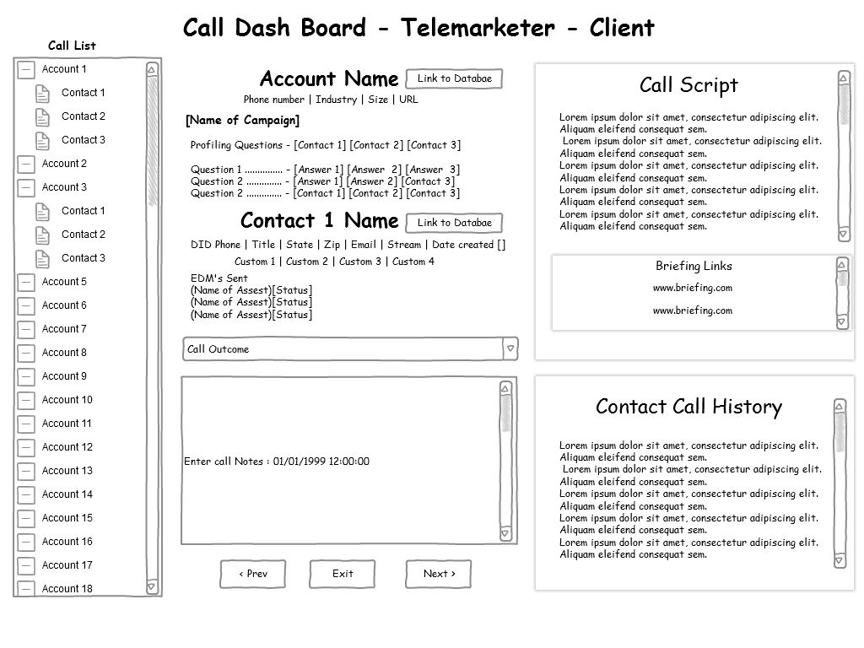

### Picture B.1 Design 1 Wireframe Telemarketing Screen 1024 x 768.

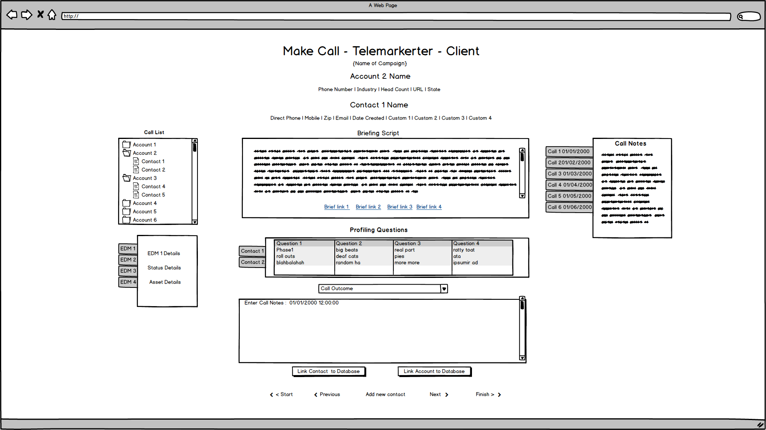

### Picture B.2 Design 2 Wireframe Telemarketing Screen 1920 x 1080.

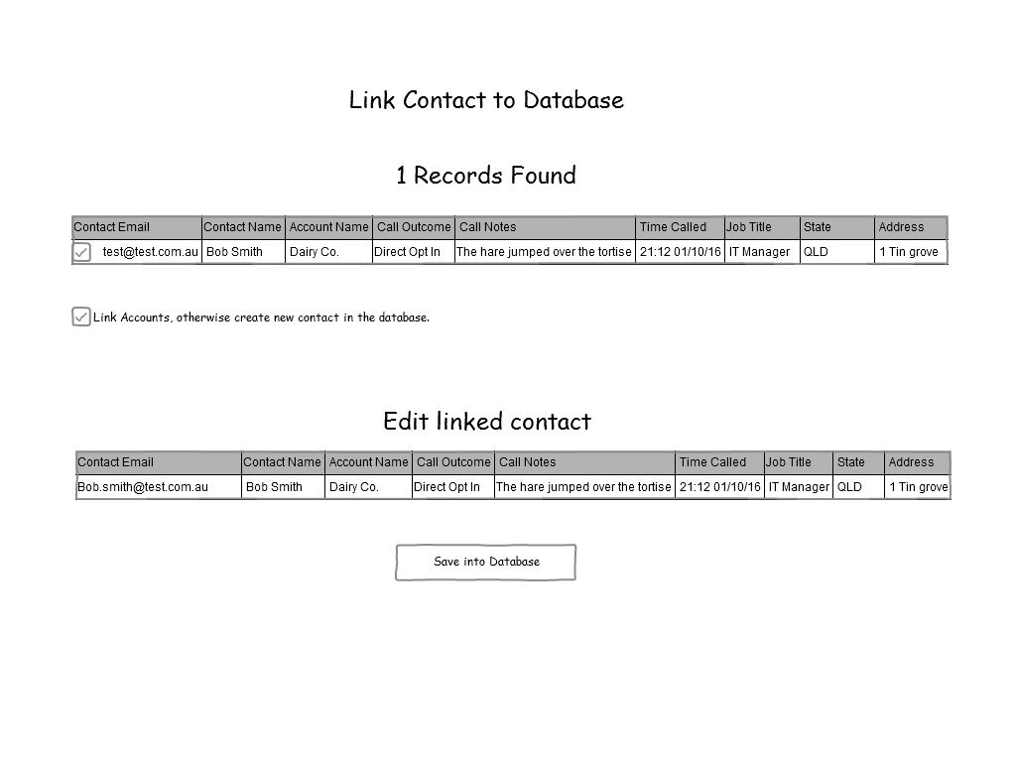

### Picture B.3 Wireframe Account Database linking screens

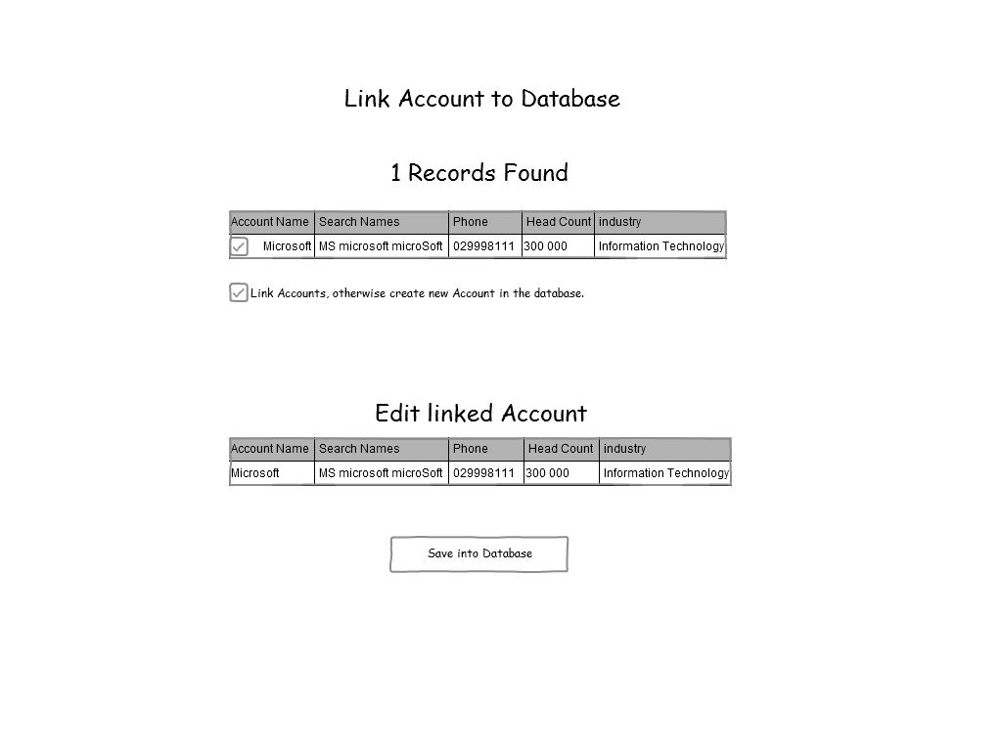

### Picture B.4 Wireframe Contact Database linking screens

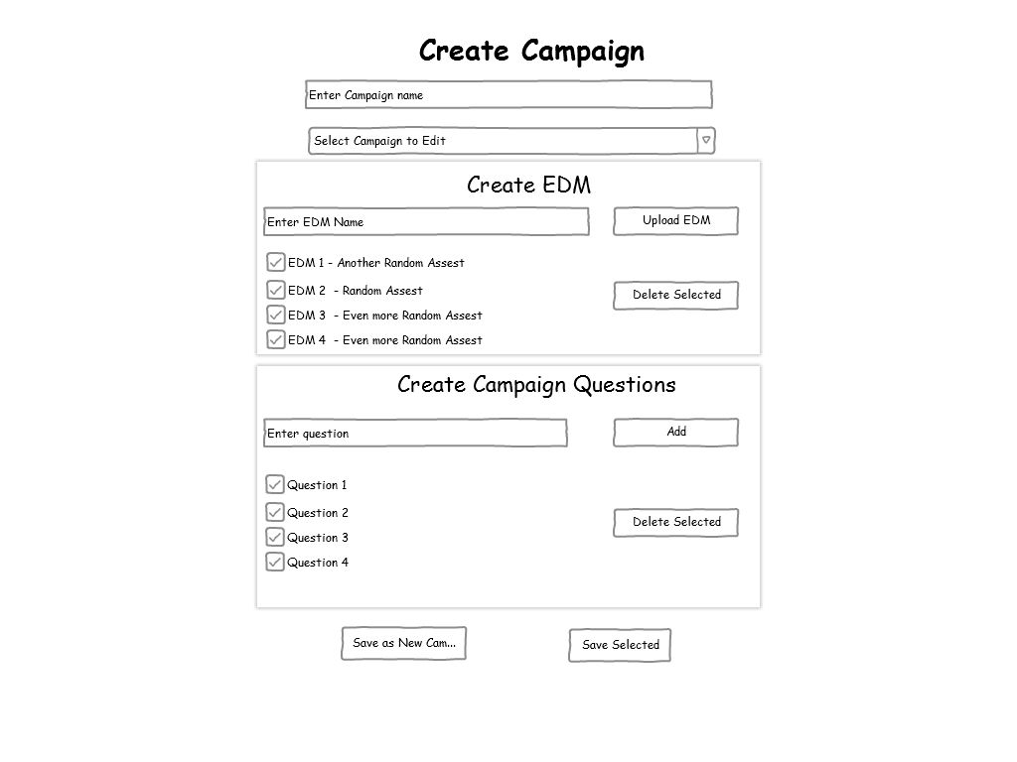

### Picture B.5 Create Campaign Screen

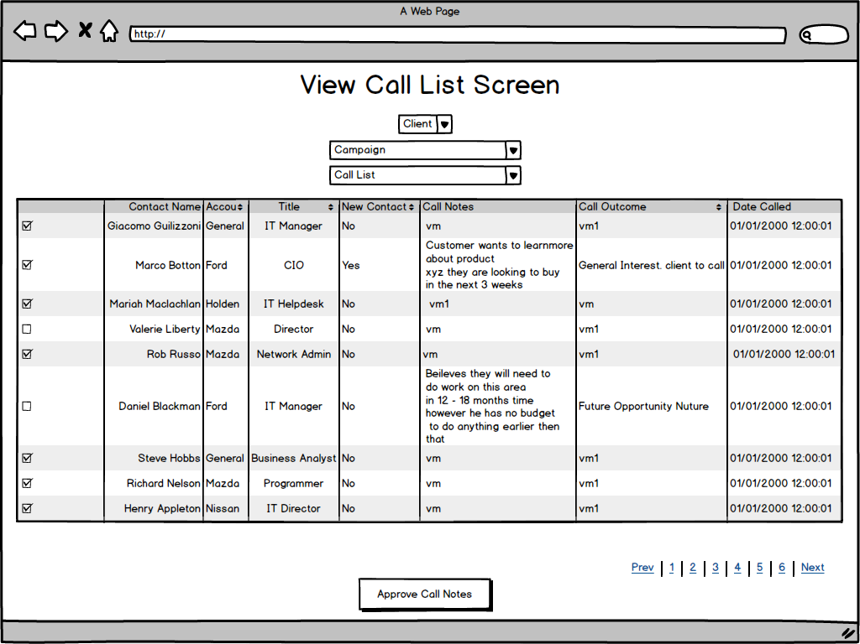

### Picture B.6 Call list outcome review screen